Mettre à jour!

Questions/Réponses
FAQ = “Foire Aux Questions” / “Frequently Asked Questions” ... et quelques réponses.

Enregistrer une image (Render)
- Render > Image
- Image > Save as Image

Set Origin
Tools > Edit > Set Origin

Cursor 3D
Shit + [S]

Grid/Grille
- Display > Grid

Units/Unités
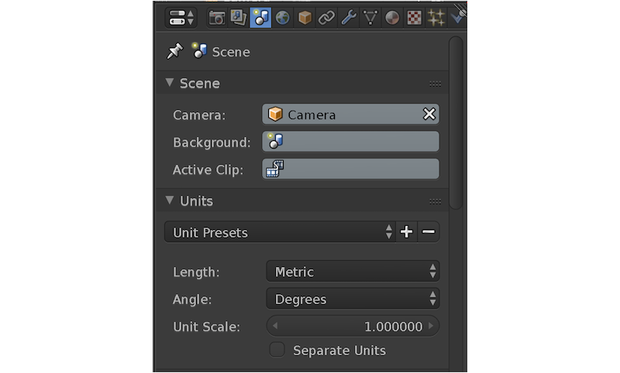

Joindre/Join
- Sélectionner 2 Meshs + [J]

Camera View
- Camera View [0]
- View > Lock Camera to View

